Integrated Systems Design

Commencing with the 2013 year Formula SAE Competition, a new integrated business/design concept summary is to be submitted by all teams, 6-9 months ahead of the competition. This summary (entitled The FSAE Business Logic Case) should not be an onerous task and will assist teams to follow an integrated systems approach. In order to give students the maximum benefit, it is intended that this task is completed before the design process is engaged with the objective to define an integrated overall vehicle concept with consideration of but not limited to: vehicle performance, cost and target market.

It will assist students understanding of, and correlation with, the real world approach to vehicle design, whereby a Total Systems Overview and Vehicle Level Targets are developed (Cost; Price; Profit; Volume; Performance), and a sanity check completed, before any detail design is undertaken. This approach can help avoid conflicts later in the design process between systems and ensure realistic targets for your total vehicle are set which can then be deployed into the function and cost targets for each of the vehicle Systems and Sub-Systems.

Why Make this Change?

At various events worldwide a rise has been observed in the number of entrants that appear to have lost their way with regards to cost, value and the logic of design for manufacture and profit. These aspects are critical in the real world you will encounter within the global automotive OE and Supplier industry. The intent of this additional submission is to help you to guide yourselves to produce a better vehicle and advance your education in line with future reality.

Seldom is the biggest budget or most expensive and technologically advanced vehicle the best solution. Getting the balance right is the key. Thinking at the higher (overall vehicle) level before plunging into the detail (the front suspension or monocoque body) will help you produce the best result within the resources available to your team.
The aim of the event series is to improve a student’s knowledge in a manner that will be real world useful, as soon as possible, and thus provide a shortcut of “experience” to the benefit of the student, their educational establishment and also their first employer. Uniquely, everyone wins here.

Remember that this is not a motorsports competition but the development of expertise and understanding of what is necessary to design, build and develop an actual vehicle that can be compared to others but which recognises the importance of cost and understanding of design and function, inside a reasonable business case. The small open wheeler with specification limits is chosen as it provides a vehicle type which can realistically be designed and built within the available time, and its actual performance then demonstrated vis a vis design intent.

This document will not be formally marked and no specific points will be allocated but it will be used to aid the Design, Cost and Business Presentation process and help teams to represent themselves consistently across the 3 static events

The Integrated Plan

The general rules which apply to this submission are summarised on Page 2. The general steps vehicle project teams would follow in developing their Business Case and related initial vehicle concept and features (in Business as well as for this event) are outlined on Page 3 along with the instructions for filling in the 1 page submission (Page 4).

The organisers appreciate that things may change; it is not intended to limit or restrict the benefits of “learning by doing” but rather to ensure that changes which arise are recognised and related back to the overall objectives. This will assist explanations to Judges at the event in a logical (and desirably documented) manner and avoid being surprised by obvious questions on the rationale for various design or feature selections.
Rules

Business Logic Case

1 The Objectives of the Business Logic Case are to:
- Teach participants about the factors that need to be considered when a company embarks on development of a new product. These include: cost; identification of market and likely sales volume; profitability; the key features applicable to the selected vehicle concept and target market size.
- Ensure teams develop the concept of their entry with all of these aspects correctly considered, from the outset.
- Ensure that all three static events are approached with a single common concept and presented to each set of static judges in the same manner.
- Ensure participants gaining experience in producing a business case and balancing potentially conflicting attributes.

2 The Design, Cost and Business Presentation judges will use the business logic case to verify that the information presented at each static event is consistent with the overall objectives as outlined in the Static Events Rules.
- In the Design event, the business logic case will be used to identify how the team determined the trade off between design for performance and design for manufacture and cost, how these requirements were considered in the overall concept and whether these were achieved in the final vehicle.
- In the Cost event, the business logic case will be used to determine that the cost target was met for the same design solution and how Cost was integrated into the overall concept and the iterative design process.
- In the Business Presentation event, the business logic case will be used to assess whether the business presentation is appropriate for the market and business strategy that the team has identified
- For some Formula Student/FSAE Events, if the event is over subscribed, then the entry selection process may include assessment of the quality of the Business Logic Case supplied.

3 All teams must submit a Business Logic Case report in accordance with the general format applicable for the year of competition “FSAE Business Logic Case 201X”. The report must be submitted on the 1 page template.
Refer to the applicable competition website to acquire the templates

4 This report must be submitted ~ 6-9 months before the competition.
Refer to the deadlines posted on the website for each specific competition.

General Requirements

The steps in developing the case generally will consist of
- benchmarking (analysis of previous competition results, competitor vehicle specifications and costs etc.)
- short listing preferred concepts
- assessing your team (company) capability to deliver different concepts recognising the budget and team that you have
- selecting your initial concept and developing targets to be achieved by the total vehicle (these will include target overall cost; likely sales potential; major performance and handling targets; timing plan for progressing the project;)
- deciding on how to break down the total vehicle cost into different areas of the vehicle, recognising the performance targets you have set.
- commencing your design to deliver the design concept and related targets recognising that the ensuing process will often be iterative and trade-offs will be necessary but if you have never defined the overall concept and what you plan to achieve, you will not be able to control your program and measure your progress

Instructions: Complete the information request fully but the submission is to be only a single A4 page. Please replace all text which is highlighted with a yellow background.
You can re-allocate space between sections versus the indicated box sizes on the pro-forma.

This case outlines the team’s decisions made throughout the overall design process and will be used in all static events at the competition.

Market Data

Table 1 below defines the maximum number of autocross vehicles that can be sold annually for a given price, but this can only be achieved if the vehicle has sufficiently high performance. 1,000 units per annum is the maximum volume available.

Your selection of Price and Volume must correlate to this table. (Interpolate as necessary). Obviously your target Vehicle Cost must also relate to your planned Price.

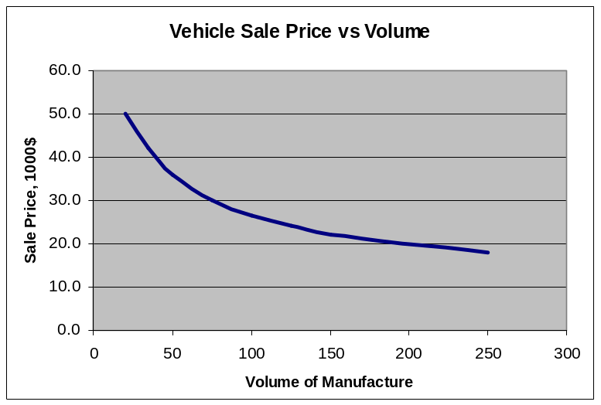
Volume of cars sold per year | Sale Price, $
20 | 50000
35 | 42000
50 | 36000
75 | 30000
100 | 26500
125 | 24000
150 | 22000
250 | 17900
500 | 14600
750 | 13400
1000 | 12600
Table 1 – Volume of sales vs. sale price

A Minimum size Font of Arial 10 must be used for completing the Pro- Forma.
Institution/Team Identification: ___________________________________

Analysis of Market Data
Ampiezza del mercato, competitors, trend del mercato, prospettive trend relative all elettrica, dove si posizionano I competitors nel mercato.

Company Strategy
All’interno di quale mercato dove ci posizioniamo e con quale strategia

Target Selling Price | Eg. 36,000
Target Vehicle Production Cost | Eg. 30,000
Target Production Volume (from Table 1) | Eg. 50
Target Annual Profit | Eg. 300,000
(Any Other targets team has identified as critical to achievement of strategy success)

Vehicle Strategy & Performance

La nostra auto ha prestazioni inarrivabili per le comubustion, maggiore facilità di manutenzione e costi più bassi. Facilità di trasporto perchè è piccola e puntiamo sul fattore green soprattutto per ottenere le autorizzazioni dei comuni
In che modo la nostra macchina in termini di performance è stata concepita per soddisfare la nostra strategia.

Plans for Efficient Design (and Manufacture)
Consider possible compromises between design for performance and design for manufacture/cost and outline your initial concept that will then be followed in your detail design in order to achieve the target performance, price and profitability. Summarise any conclusions and rationale.
In che modo l’auto è stata progettata e sarà prodotta in modo da soddisfare le performance sopra citate, dato il nostro prezzo target.

Key Design Features Key PerformanceTargets
Chassis/Body Type | E.g. carbon tub; steel tube | Accn. 0-75 Metres
Power train type | Eg IC engine / electric | Lateral Accn, (g)
Power / engine | Eg. 600cc twin 80bhp / electric motor – 50kW | Fuel Economy
Target weight, kg |  | Other critical performance targets – (team decides)
Other Key Feature
(Team decides)
Note: Submit only this page and replace all the text in yellow boxes with your text.

Our company core business focuses on the production of electric cars specifically designed for hill climb. For these vehicles, we will organize a series of events in a regional contest, leveraging the long-standing tradition of our area. These events will be opened to cars from different manufacturers as long as they fulfil the technical requirements of the competition. We will create a format out of these events and make it easily reproducible in other contests around the globe. We believe that our sales will grow with the spread of these format in regions that share this tradition. We target rally and hill climb enthusiasts that value innovation and technology as well as safety and practicality.

